## Information Management Group 20 Report

## CSU22041

Domain: FastFood Delivery Service

Members: Faith Olopade (21364066),Emeka David Odoemelam (20334547), Kate O Neill (21365768), Luke O Rourke (21365366), Orson O Sullivan (21360888), Kostiantyn Ohorodnyk (20336895)

# 

Information Management Group 20 Report 0

CSU22041 0

**Changes When Going From UML to XML** **2**

**Distribution of Tasks** **2**

**Strengths and Weaknesses Of The XML Design and XQueries Design** **4**

**XML and DTD Documents** **4**

**XQuery** **7**

# 

# Changes When Going From UML to XML

In order to design a XML implementation of our UML class diagram we needed to make occasional changes to the class diagram to suit the new XML format for this project.

The changes we needed to make consisted of adding new elements/attributes for added detail or to meet requirements for the XML documents and for UML class diagrams.

Some more changes we made when going from UML to XML are mentioned with each XML document description below.

# Distribution of Tasks

From our initial meeting we had a clear understanding of how tasks were going to be divided and we ensured that the division would be fair. To ensure this we scheduled weekly meetings on Discord to check in on everyone’s progress and ensure we were on schedule to meet our weekly goals. We would also discuss our goals for the next week in every meeting we had along with discussing any difficulty people were having with their assigned task.

Below is the distribution of work among ourselves across the weeks.

Week 1 (07/10):

| Member | Tasks |
| --- | --- |
| Faith Olopade (21364066) | Refining Class Diagram  Writing XML documents:   * Order Class   Researching XQueries relating to Use Case diagram |
| Kostiantyn Ohorodnyk (20336895) | Writing XML documents:   * Consumer Account Class   Researching XQueries relating to Use Case diagram |
| Orson O Sullivan (21360888) | Writing XML documents:   * Customer Service Class   Researching XQueries relating to Use Case diagram |
| Emeka David Odoemelam (20334547) | Refining Class Diagram  Writing XML documents:   * Restaurant Menu Class   Researching XQueries relating to Use Case diagram |
| Kate O Neill (21365768) | Refining Class Diagram  Writing XML documents:   * Payment Class   Researching XQueries relating to Use Case diagram |
| Luke O Rourke (21365366) | Writing XML documents:   * Restaurant Account Class   Researching XQueries relating to Use Case  diagram |

Week 2 (14/10):

| Member | Tasks |
| --- | --- |
| Faith Olopade (21364066) | Finishing XML documents and DTD’s  Developing XQueries:   * FOR Clause * WHERE Clause * LET Clause   Preparing for lab demonstration  Proofreading & Testing All XML documents and DTDs |
| Kostiantyn Ohorodnyk (20336895) | Finishing XML documents and DTD’s  Developing XQueries:   * WHERE Clause   Preparing for lab demonstration |
| Orson O Sullivan (21360888) | Finishing XML documents and DTD’s  Developing XQueries:   * Built in XQuery function * User Defined Function   Preparing for lab demonstration |
| Emeka David Odoemelam (20334547) | Finishing XML documents and DTD’s  Developing XQueries:   * Built in XQuery function * User Defined Function   Preparing for lab demonstration |
| Kate O Neill (21365768) | Finishing XML documents and DTD’s  Developing XQueries:   * WHERE Clause   Preparing for lab demonstration |
| Luke O Rourke (21365366) | Finishing XML documents and DTD’s  Developing XQueries:   * FOR Clause   Preparing for lab demonstration |

Week 3 (21/10):

| Member | Tasks |
| --- | --- |
| Faith Olopade (21364066) | Writing Report  Adding comments to XML documents |
| Kostiantyn Ohorodnyk (20336895) | Writing Report  Adding comments to XML documents |
| Orson O Sullivan (21360888) | Writing Report  Adding comments to XML documents |
| Emeka David Odoemelam (20334547) | Writing Report  Adding comments to XML documents |
| Kate O Neill (21365768) | Writing Report  Adding comments to XML documents |
| Luke O Rourke (21365366) | Writing Report  Adding comments to XML documents |

# Strengths and Weaknesses Of The XML Design and XQueries Design

**Strengths:** You can include comments of any size in XML documents. When designing the UML class diagram, we discovered that there is a limit to how many comments we can add to clarify design decisions before it gets visually overwhelming. One advantage of an XML design is that there is greater communication between the author and reader of the documents because this is not a difficulty for XML documents.

Our XQueries are straightforward but powerful. We frequently brought up the idea of making our XQueries straightforward yet practical during our discussions before to constructing them. We wanted to make sure that each XQuery served a specific goal and did it in the simplest manner feasible.

**Weaknesses:** It is difficult to visualise how the classes interact with one another, in contrast to the UML class diagram. Without reading the documents several times, it is challenging to have a thorough understanding of the system in an XML format. For XQueries, this represents a compromise between accuracy, utility, and practicality.

# XML and DTD Documents

This XML document includes the order and driver from our UML Class Diagram. Some of the changes going from UML to XML include the following:

* The addition of orderID as an attribute to the order class
* Connection added between payment and order classes
* Elements added to consumer account, payment, restaurant menu and order class

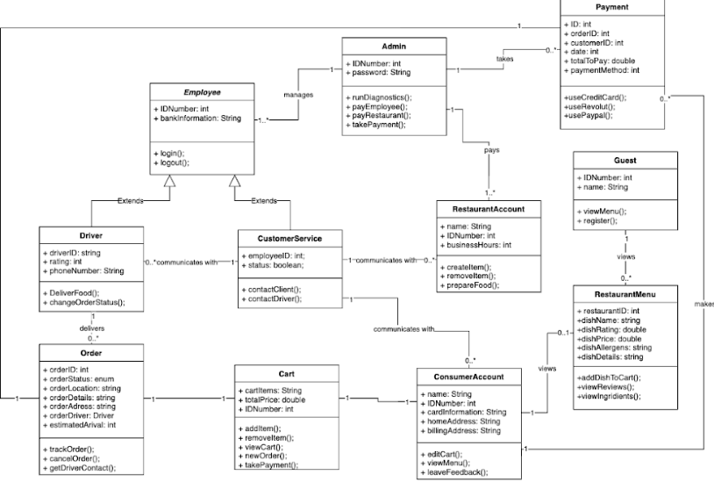

**Order**

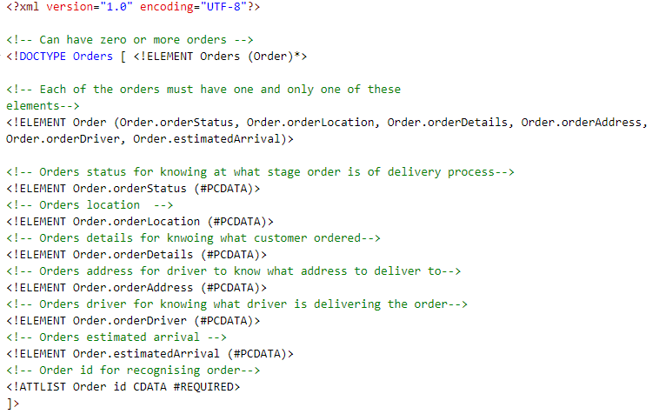

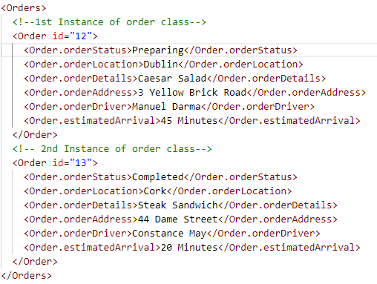

**Driver**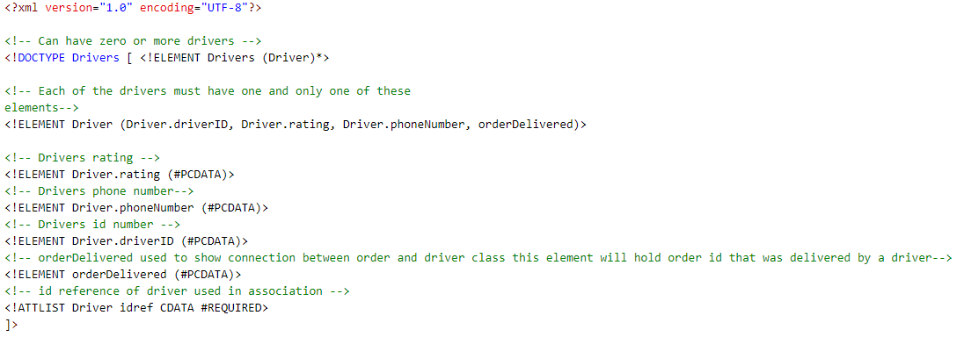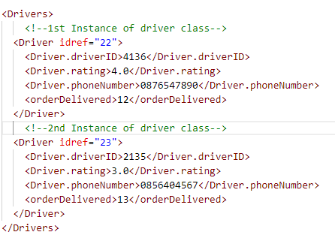

**RestaurantMenu**

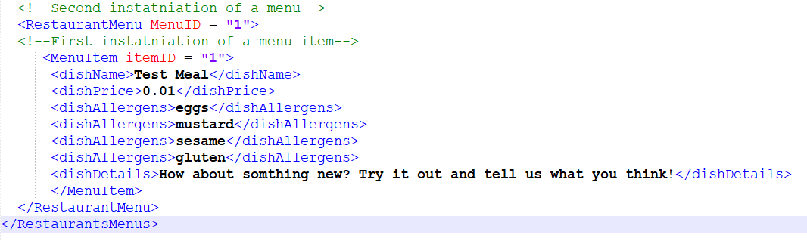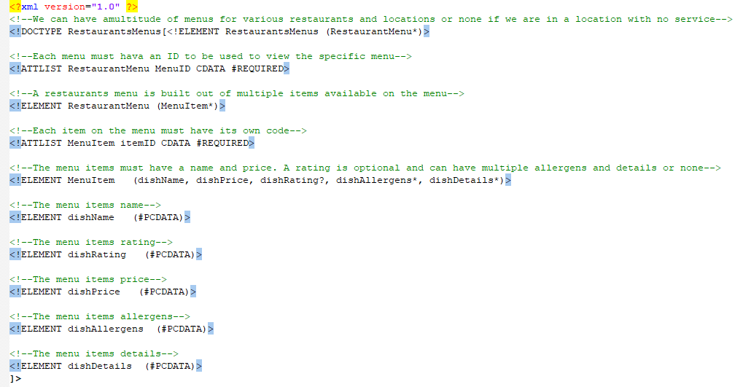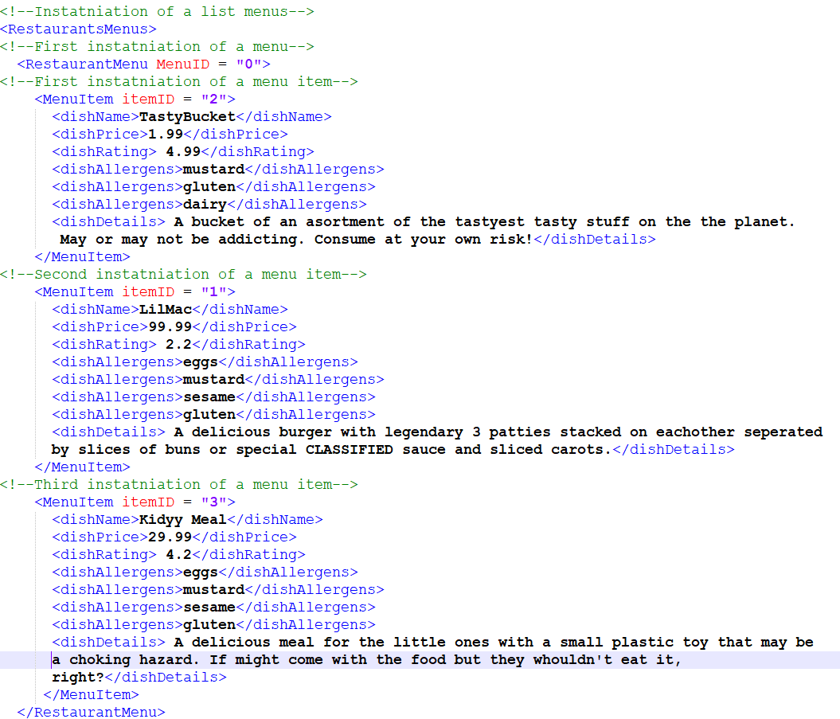

**Payment**

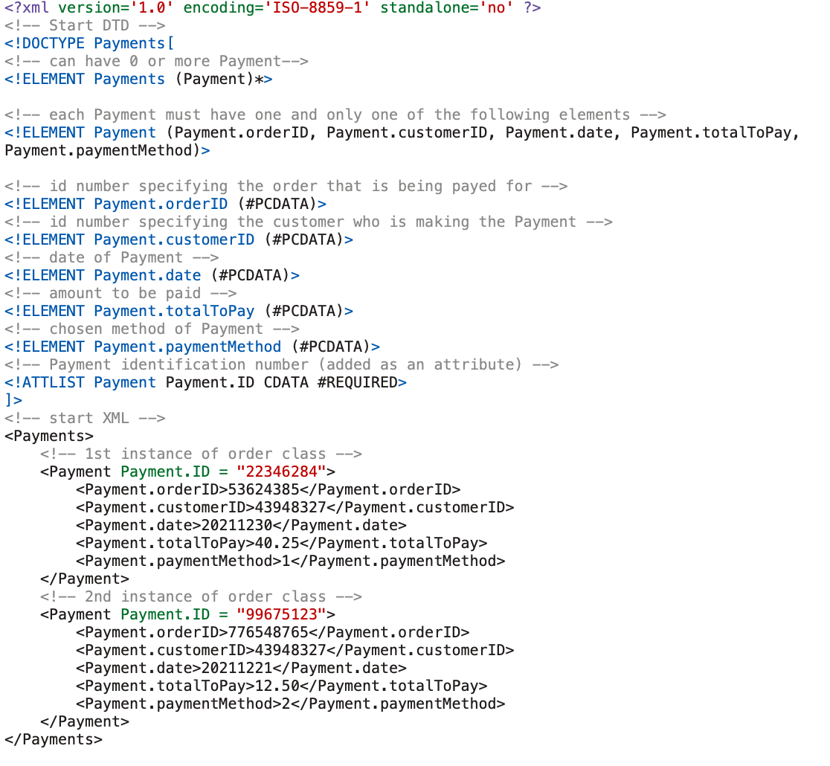

When the ConsumerAccount class would like to make an Order, the Payment class takes in a customerID and an orderID and allows the ConsumerAccount to pay for the order.

The Payment class required a few adjustments, such as replacing *name* with *customerID* so that it is connected to the CustomerAccount class, and adding paymentMethod.

**RestaurantAccount**

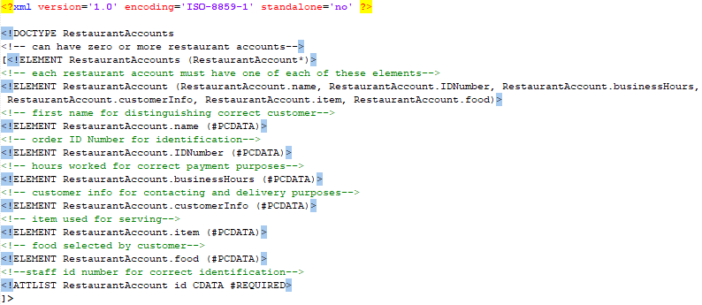

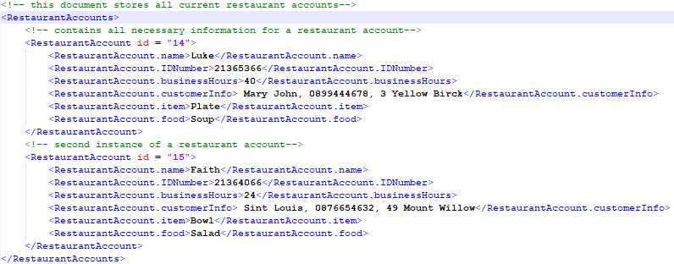

**ConsumerAccount**

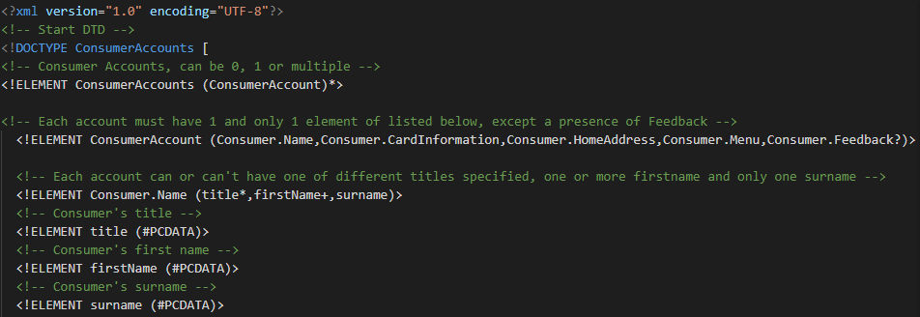

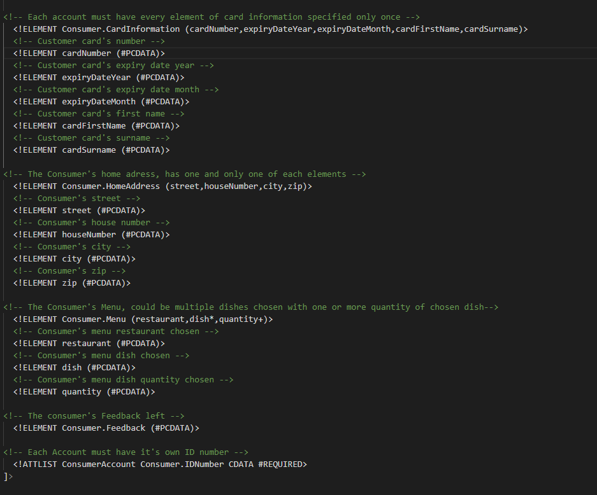

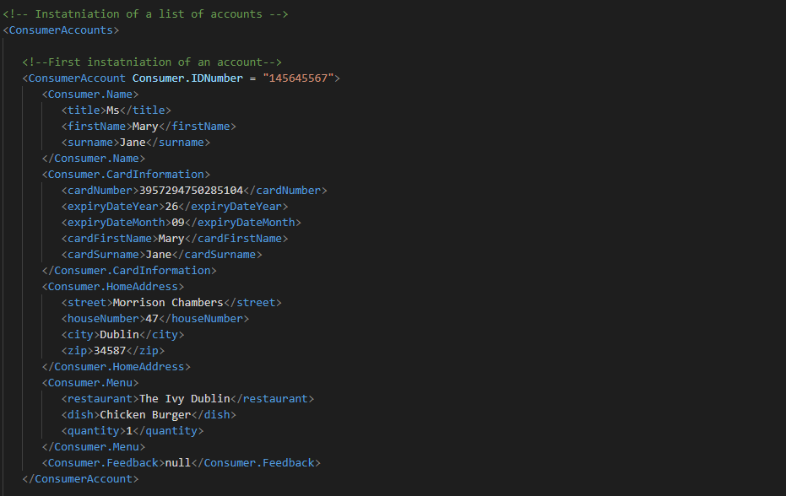

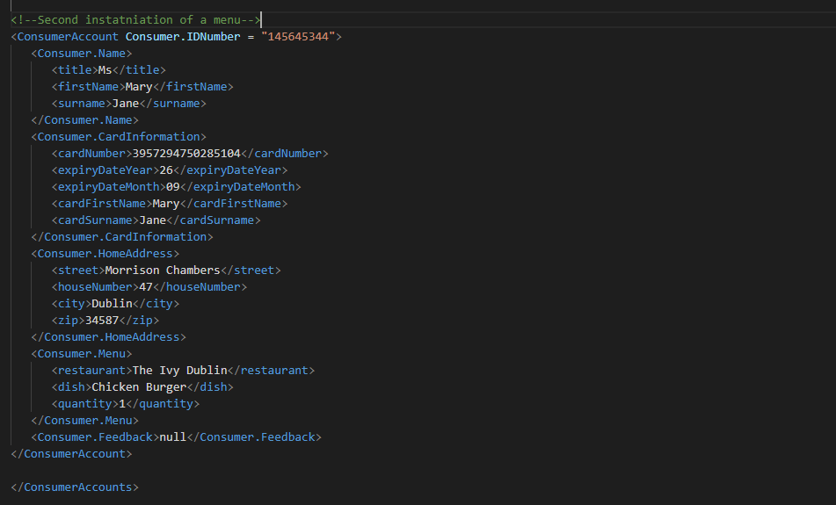

**CustomerService**

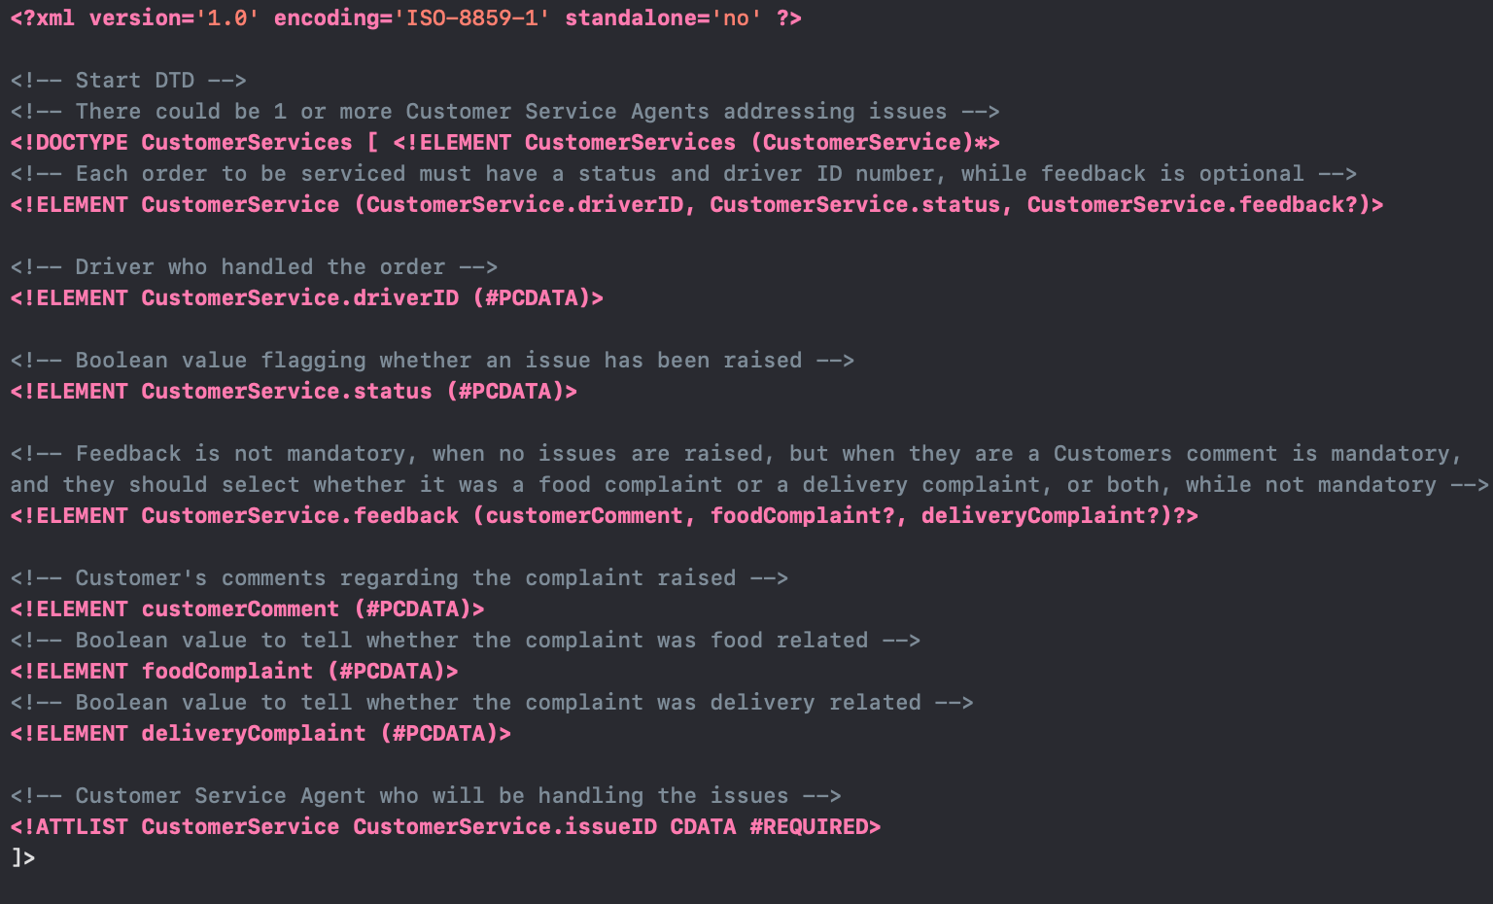

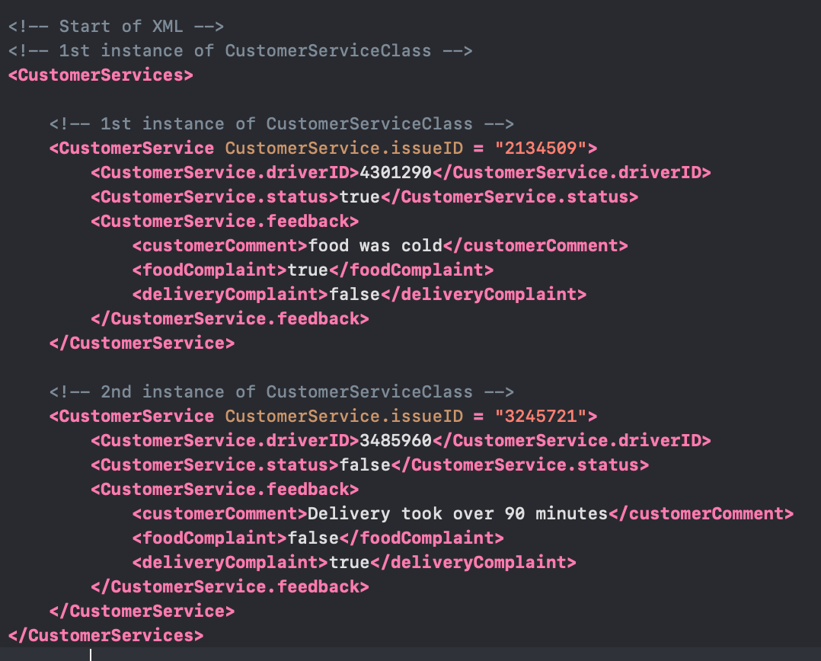

# 

# XQuery

**FOR CLAUSE.xq**

# 

**Query Author:** Faith Olopade

**Supporting UML Use-Case:**  Order Food

**Purpose of Query:** Provide customer order details. This may be useful in tracking what each customer has ordered

**Example Output:** 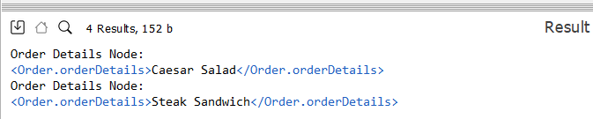

**WHERE CLAUSE Xquery.xq**

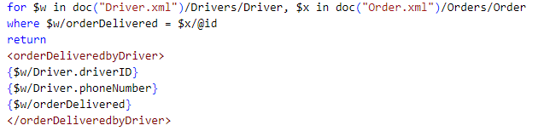

**Query Author:** Faith Olopade

**Supporting UML Use-Case:**  Deliver Food

**Purpose of Query:** Provide information on which order driver delivered. This may be useful in tracking who delivered what order in case of any issues with order

**Example Output:**

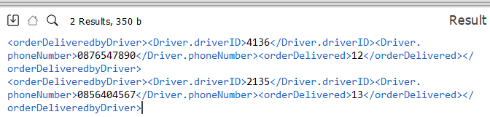

**LET CLAUSE Xquery.xq**

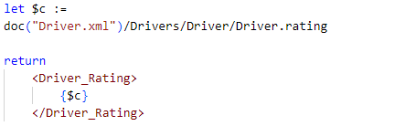

**Query Author:** Faith Olopade

**Supporting UML Use-Case:**  Deliver Food

**Purpose of Query:** Provide information on driver rating. This may be useful for customers who may want drivers with a certain rating to deliver their food

**Example Output:** 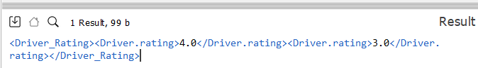

**Built in XQuery Function and User Defined Function**

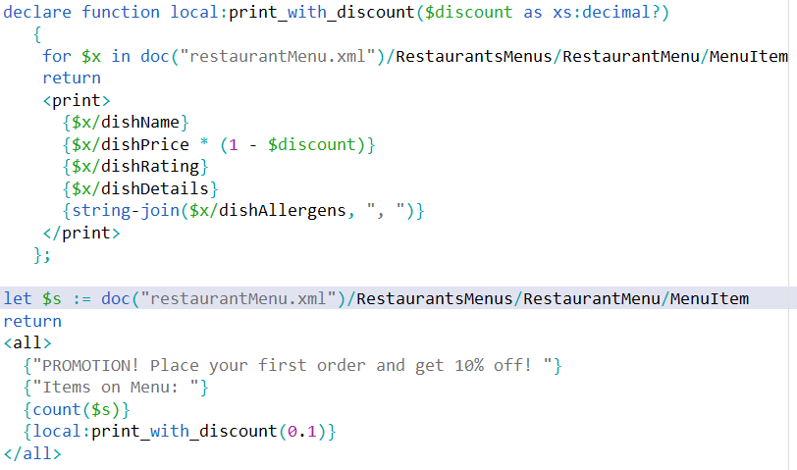

**Query Author:** Emeka David Odoemelam

**Supporting UML Use-Case:**  Order Food

**Purpose of Query:** Print out the menus available with a platform wide 10% discount on an order.

**Example Output:**

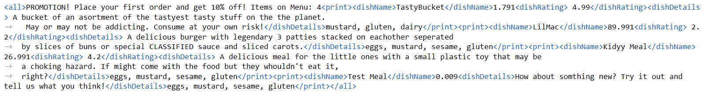

# 

# 

# 

# 

# 

# 

# 

# 

# 

# **WHERE_CLAUSE.xq**

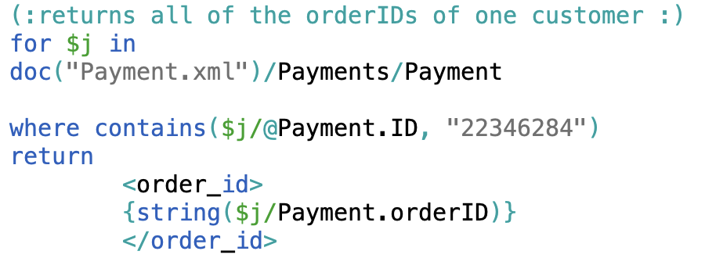

**Query Author:** Kate O Neill

**Supporting UML Use-Case:** Pay Online

**Purpose of Query:** Return all orders to be paid by customer.

**Example Output:**

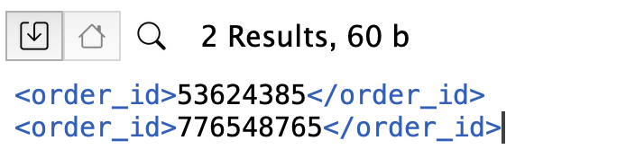

**FOR CLAUSE.xq**

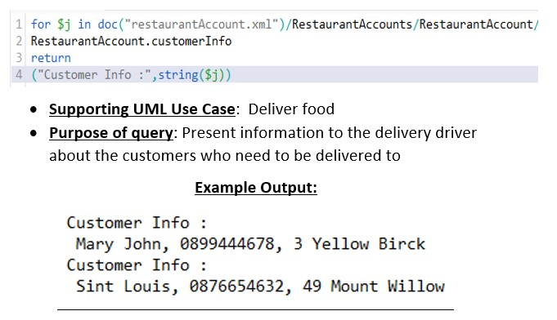

**Query Author:** Luke O Rourke

**WHERE_CLAUSE.xq**

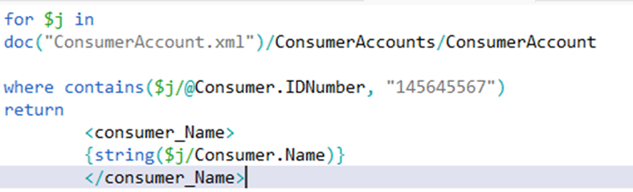

**Query Author:** Kostiantyn Ohorodnyk

**Supporting UML Use-Case:** Deliver Food

**Purpose of Query:** Search and manage consumer’s account information like their name, address, feedback etc. by their accounts’ ID number. This information is useful when asking for customers’ payments or giving drivers their addresses

**Example output:**

**Built in XQuery Function and User Defined Function**

**Query Author:** Orson O’Sullivan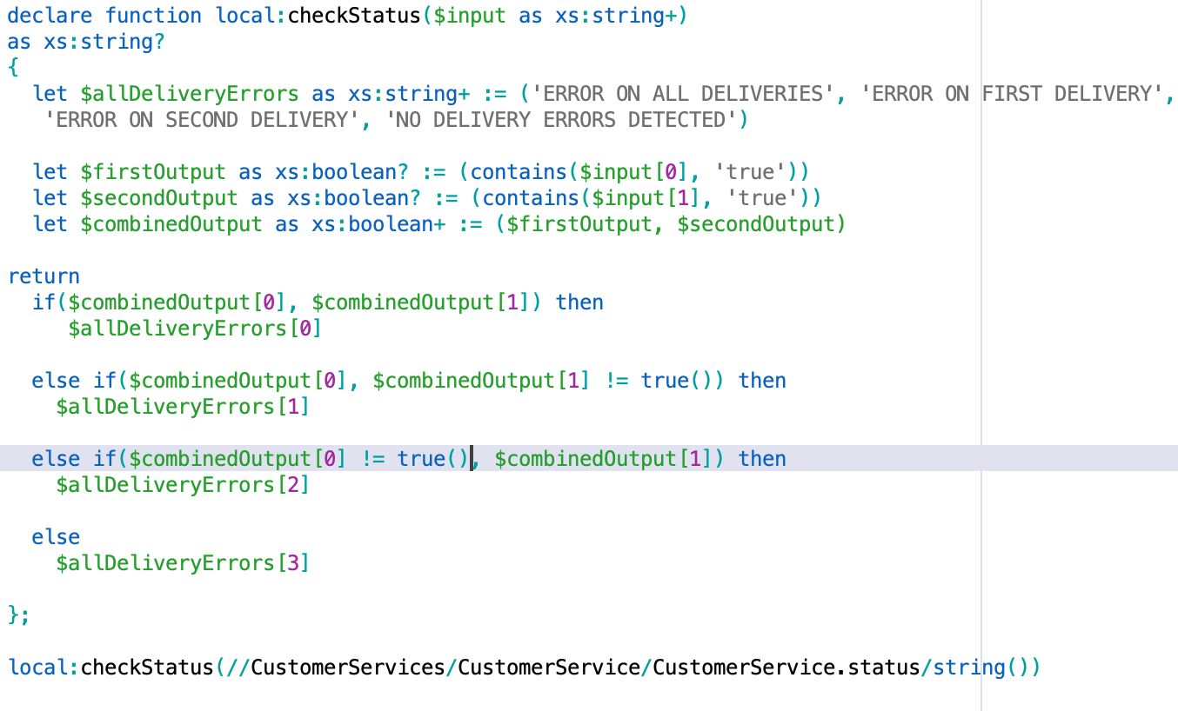

**Supporting UML Use-Case:** Monitors Deliveries and Payment

**Purpose of Query:** Allows the customer service agent to quickly filter whether either of the deliveries have had any issues that need to be remedied. ( checkStatus is the user defined function, while contains() is the XQuery function).

**Example output:**